**Assignment 6.2**

**Associated Data Files**

<https://drive.google.com/file/d/0Bxr27gVaXO5sa0JBamZXdkpYUFk/view?usp=sharing>

**Problem Statement:**

* Fetch date and temperature from temperature_data where zip code is greater than 300000 and less than 399999.

select date , temperature

from temperature_data

where zip_code>300000 and zip_code<399999

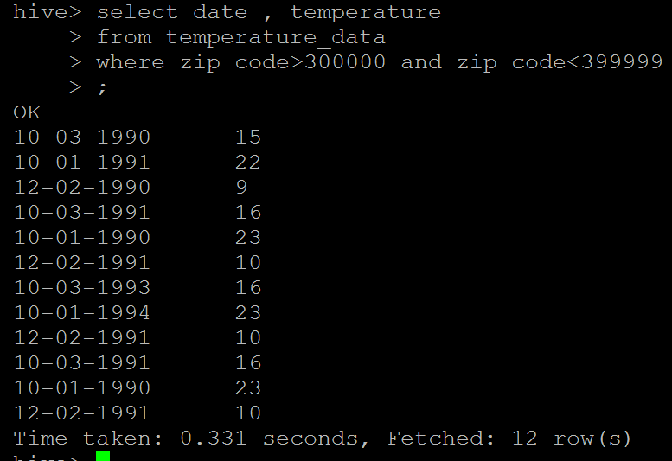

* Calculate maximum temperature corresponding to every year from temperature_data table.

select substr(date,7),max(temperature) from temperature_data group by substr(date,7);

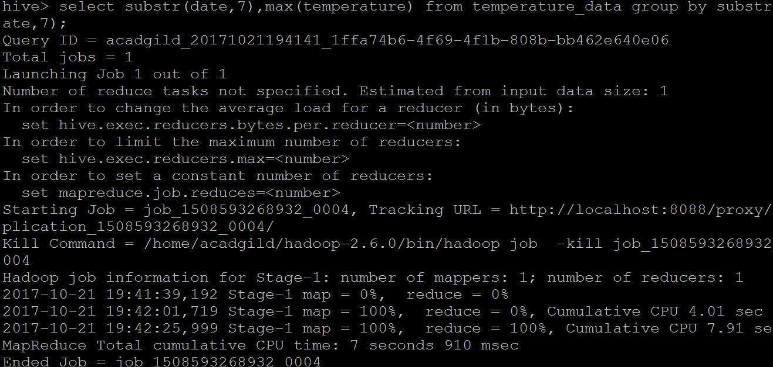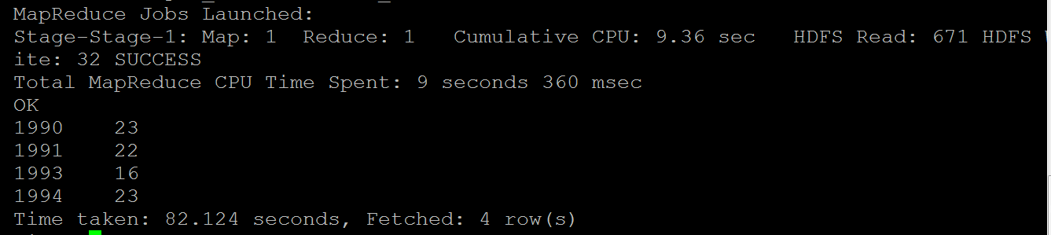

* Calculate maximum temperature from temperature_data table corresponding to those years which have at least 2 entries in the table.

select substr(date,7),max(temperature) from temperature_data group by substr(date,7) having count(temperature)>1;

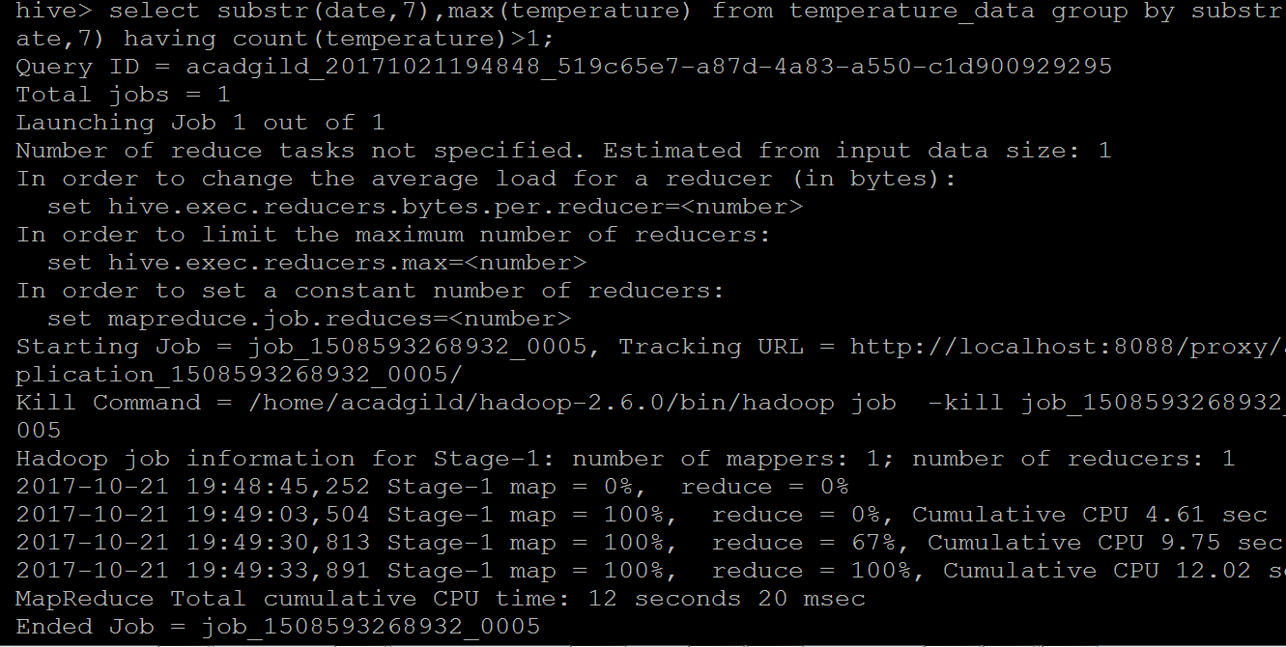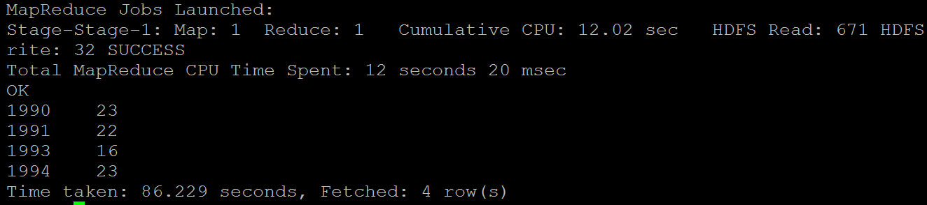

* Create a view on the top of last query, name it temperature_data_vw.

create view temperature_data_vw select substr(date,7),max(temperature) from

temperature_data group by substr(date,7) having count(temperature)>1;

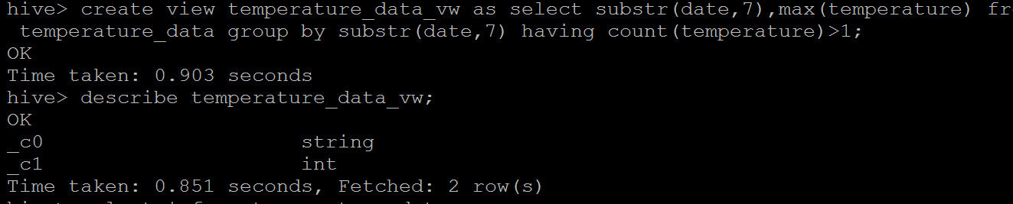

**verification**

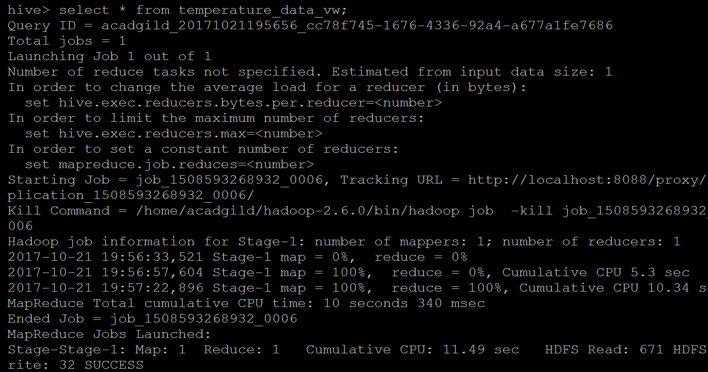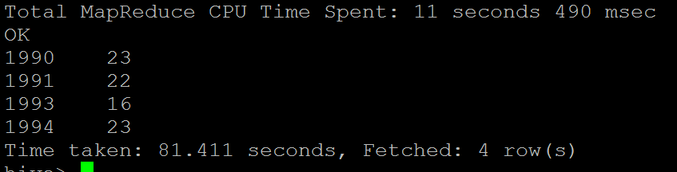

* Export contents from temperature_data_vw to a file in local file system, such that each file is '|' delimited.

insert overwrite local directory 'hive_temperature_data_vw' row format

delimited fields terminated by '|' select * from temperature_data_vw;

